**Program:** Write a program that reads 10 positive numbers from the keyboard and determines and displays the sum and average of the numbers.

|  |
| --- |
| /*Program for calculating sum and average (using for loop)*/  #include <stdio.h>  #include <conio.h>  int main ()  {  int i;  float n,sum=0,avg; //Avg for average  printf ("Enter Ten Positive Numbers: ");  for (i=1;i<=10;i++) //for-loop running 10 times  {  scanf ("%f",&n);  sum=sum+n;  }  avg=sum/10;  printf ("Sum = %.2f\nAverage = %.2f",sum,avg); //output  return 0;  } |

**Exercise 1:**

**Program name:** Sum of even numbers

**Program Purpose:** Use of while loop

**Problem Statement:** Write a C program that uses a while loop to calculate and print the sum of the even integers from 6 to 30.

**Exercise 2:**

**Program name:** Very simple calculator continuous

**Program Purpose:** 1. Using Sentinel-controlled loop, 2. Using do-while loop.

**Problem statement:** You haveto write the same “Very simple calculator” program which you have written earlier. But, this time the program asks the operator and the operands again and again, until the user ends the program. This program works as follows.

1. Input the two operators (numbers on which the operation will be performed).
2. Input the operator.
3. Perform the operation and display the result.
4. Ask the user whether he wants to perform the operation again. If the user enters ‘y’ then goto step 1, otherwise terminate the program by showing some leaving message.

**Exercise 3:**

**Program name:** Average of pre-specified number of integers

**Program Purpose:** using break statement

**Problem statement:** Write a program which allows user to compute average of a pre-specified number of values input by him. But, if the user enters a negative number during user-input, the program should stop taking any more input from user. The program works as follows.

1. Asks the user how many number of integers he wants to enter.
2. Input the numbers from user (inside loop).
3. Compute the sum (inside loop) as the numbers are entered.
4. If the user enters a negative loop, stop taking any more input from user.
5. Show the average of numbers entered so far.

**Sample Output:**

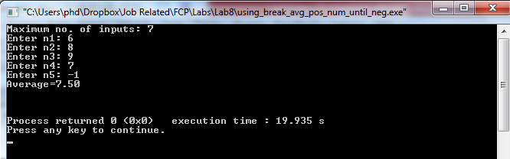

/* C program to demonstrate the working of break statement by terminating a loop, if user inputs negative number*/

# include <stdio.h>

int main(){

float num,average,sum;

int i,n;

printf("Maximum no. of inputs\n");

scanf("%d",&n);

for(i=1;i<=n;++i){

printf("Enter n%d: ",i);

scanf("%f",&num);

if(num<0.0)

break; //for loop breaks if num<0.0

sum=sum+num;

}

average=sum/(i-1);

printf("Average=%.2f",average);

return 0;

}

**Exercise 4:**

**Program name:** Multiplication of a pre-specified number of integers (excluding 0)

**Program Purpose:** using continue statement

**Problem Statement:** Write a program which allows user to multiply a pre-specified number of values input by him except the 0 values. The program works as follows.

1. Asks the user how many number of integers he wants to enter.
2. Input all the numbers. (Hint: inside loop)
3. Multiply all the input numbers excluding 0’s (Hint: use continue statement for this)
4. Show the output of multiplication.

**Sample Output:**

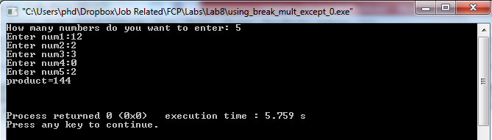

//program to demonstrate the working of continue statement in C programming

# include <stdio.h>

int main(){

int i,num,product;

for(i=1,product=1;i<=4;++i){

printf("Enter num%d:",i);

scanf("%d",&num);

if(num==0)

continue; / *In this program, when num equals to zero, it skips the statement product*=num and continue the loop. */

product*=num;

}

printf("product=%d",product);

return 0;

}

**Exercise 5:**

**Program Name:** Print prime numbers between two intervals

**Purpose:** Usage of nested loops

**Problem Statement:** Prime number is a number which is not divided by any number other than 1 and the number itself.Write a program to display all prime numbers between two intervals entered by the user. (Hint: use nested for loops and break statement).

**Sample output:**

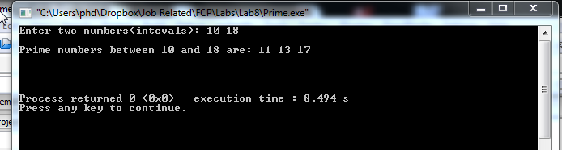

/* C program to display all prime numbers between Two interval entered by user. */

#include <stdio.h>

int main()

{

int n1, n2, i, j, flag;

printf("Enter two numbers(intevals): ");

scanf("%d %d", &n1, &n2);

printf("Prime numbers between %d and %d are: ", n1, n2);

for(i=n1+1; i<n2; ++i)

{

flag=0;

for(j=2; j<=i/2; ++j)

{

if(i%j==0)

{

flag=1;

break;

}

}

if(flag==0)

printf("%d ",i);

}

return 0;

}